## projects table

## Fields

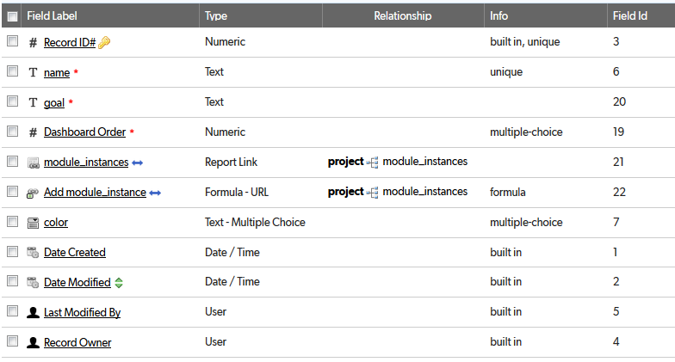

## Relationships

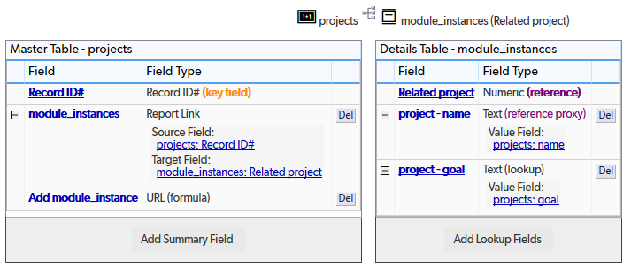

## Field settings

Note: Built-in fields use the default settings

name 3

goal 5

Dashboard Order 7

module_instances 9

Add module_instance 10

color 12

# name

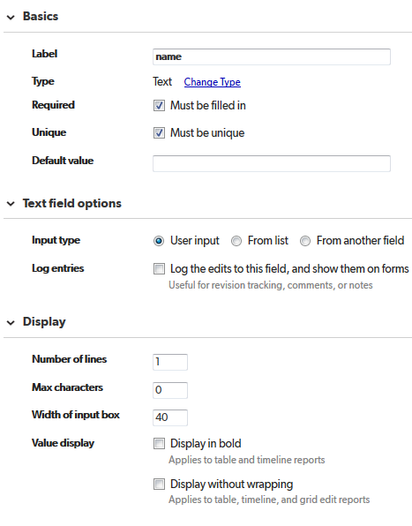

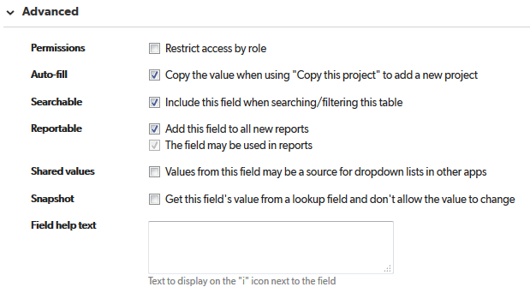

# goal

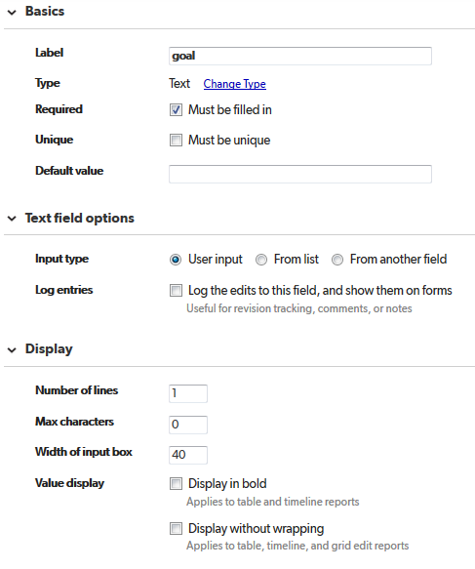

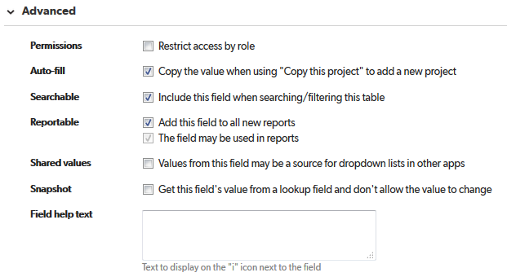

# Dashboard Order

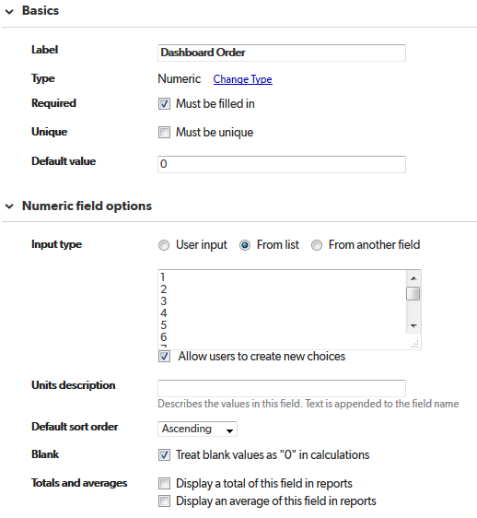

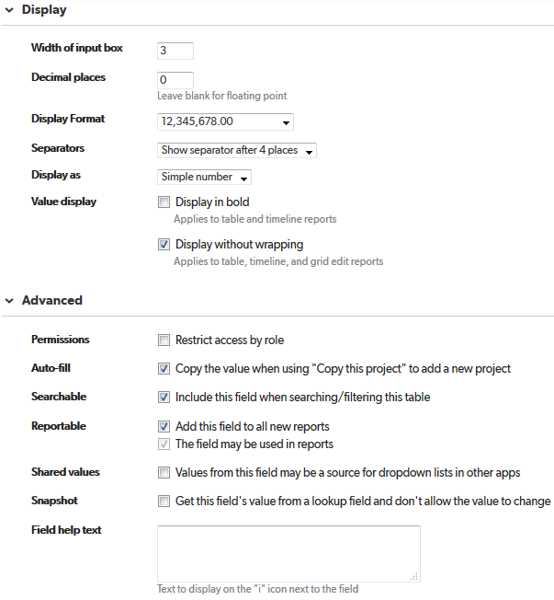

# module_instances

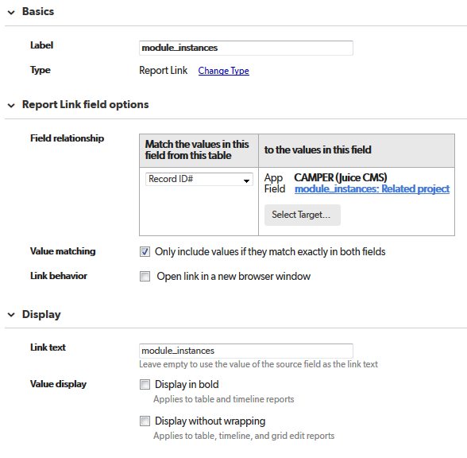

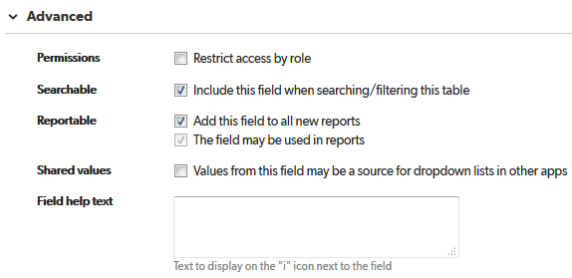

# Add module_instance

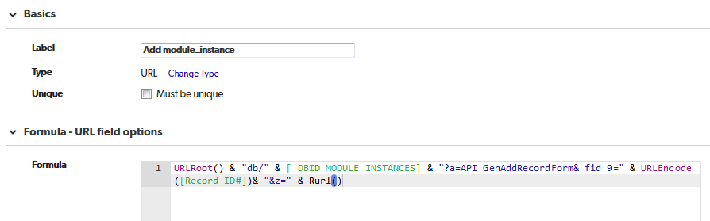

URLRoot() & "db/" & [_DBID_MODULE_INSTANCES] & "?a=API_GenAddRecordForm&_fid_9=" & URLEncode ([Record ID#])& "&z=" & Rurl()

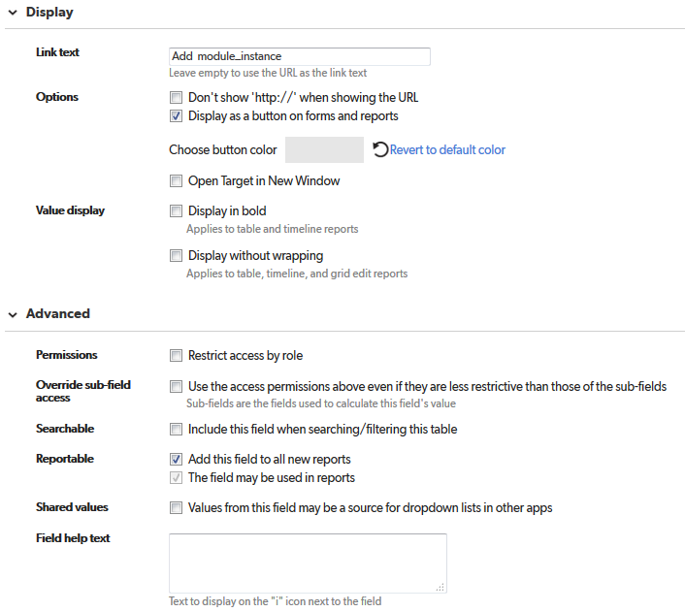

# color

